ASSIGNMENT 2 – IOT

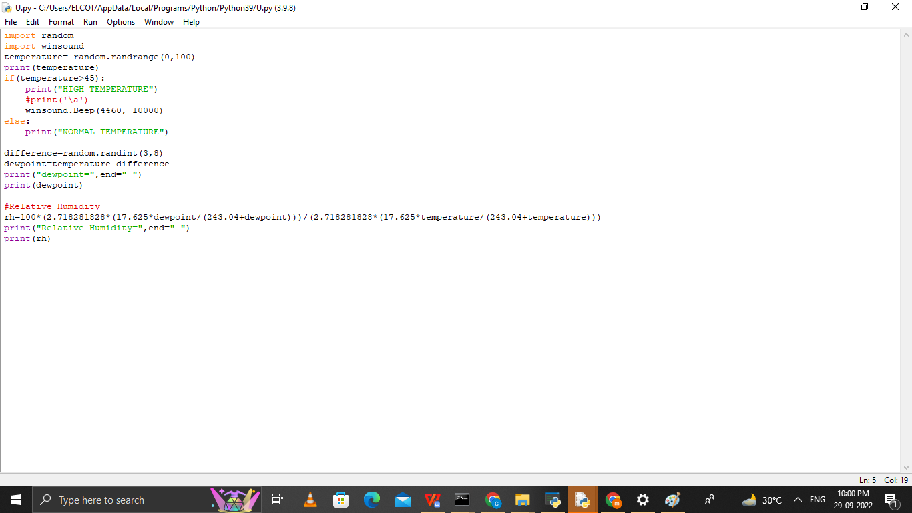

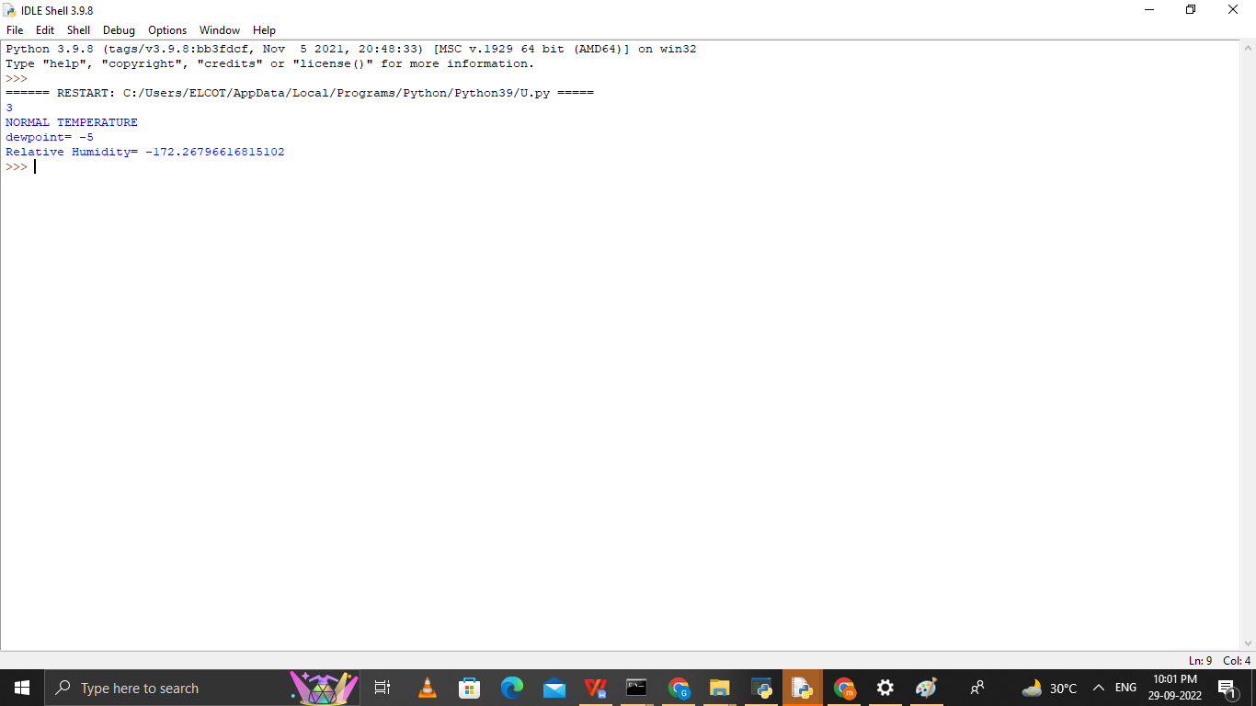

PROGRAM CODE:

import random  
import winsound  
temperature= random.randrange(0,100)  
print(temperature)  
if(temperature>60):  
    print("HIGH TEMPERATURE")  
    #print('\a')  
    winsound.Beep(4460, 10000)  
else:  
    print("NORMAL TEMPERATURE")  
     
difference=random.randint(3,8)  
dewpoint=temperature-difference  
print("dewpoint=",end=" ")  
print(dewpoint)  
  
#Relative Humidity  
rh=100\*(2.718281828\*(17.625\*dewpoint/(243.04+dewpoint)))/(2.718281828\*(17.625\*temperature/(243.04+temperature)))  
print("Relative Humidity=",end=" ")  
print(rh)

LINK:

https://photos.app.goo.gl/dJLEvFdhPi6TmArP8